This is the template file for the 15th Dusty Plasma Workshop
Title: Centered, 14 point, Bold

Jack Author¹, Jill Writer¹, and A. Einstein²
¹ University of Maryland, Baltimore County, MD USA
² Centered, 12 point
einstein@goodscience.com (email address of presenting author)

Enter the text for the abstract beginning here. The abstract can be up to one full page using US Letter format (8.5 inches wide x 11 inches tall) sheets. The margins should be 1.5 inches (left), 1.0 inches (top), 1.0 inches (bottom), 1.0 inches (right). All text should be single spaced, justified, and 12 point Times or Times New Roman. Figures and references can be included in the abstract as long as it fits within the space provided. Please submit the abstracts in PDF format when using the online submission form.

All text and no good science makes Jack a dull boy. All text and no good science makes Jack a dull boy. Game over man, game over! All text and no good science makes Jack a dull boy. All text and no good science makes Jack a dull boy. All text and no good science makes Jack a dull boy. All text and no good science makes Jack a dull boy. He who controls the spice, controls the universe. All text and no good science makes Jack a dull boy. All text and no good science makes Jack a dull boy. All text and no good science makes Jack a dull boy. Open the pod bay doors HAL. All text and no good science makes Jack a dull boy. All text and no good science makes Jack a dull boy. Say hello to my little friend. All text and no good science makes Jack a dull boy. All text and no good science makes Jack a dull boy. All text and no good science makes Jack a dull boy. The force will be with you, always. All text and no good science makes Jack a dull boy. All text and no good science makes Jack a dull boy. All text and no good science makes Jack a dull boy. Live long and prosper. All text and no good science makes Jack a dull boy. All text and no good science makes Jack a dull boy. All text and no good science makes Jack a dull boy.

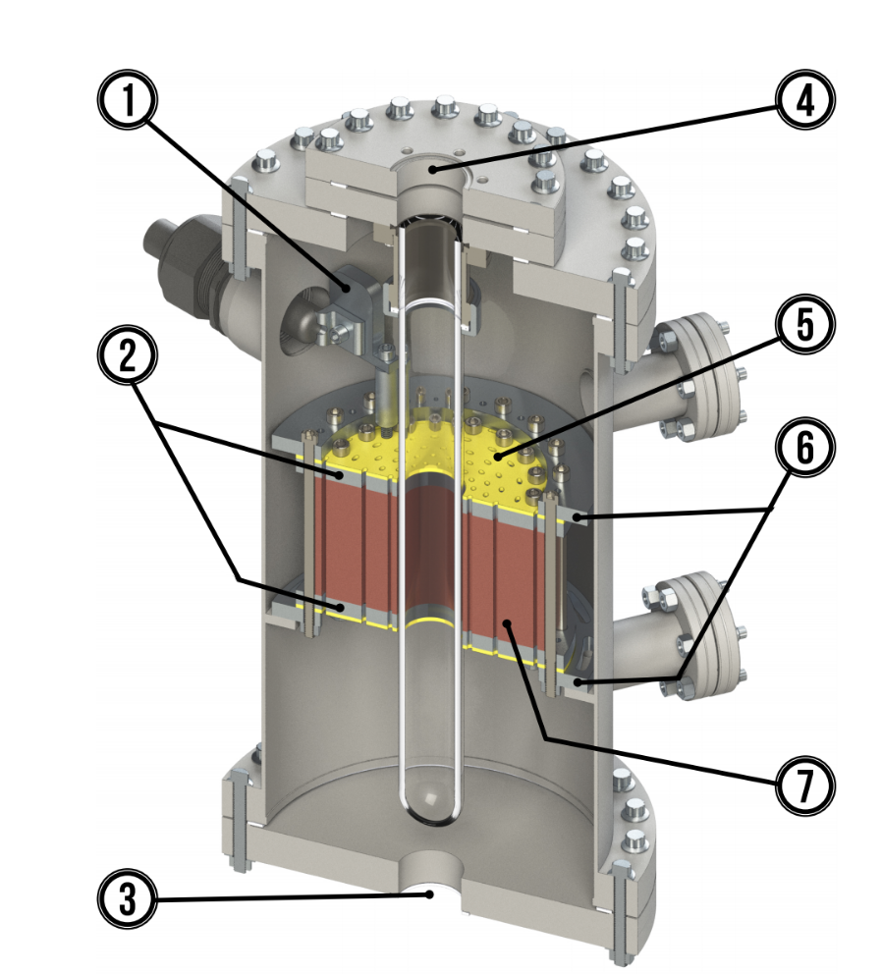
Figure 1 – Add a figure if appropriate, as long as it can fit in one page. Include a brief caption.

